**APPENDIX – SCREEN SHOTS**

Some of the screenshots of this project is presented

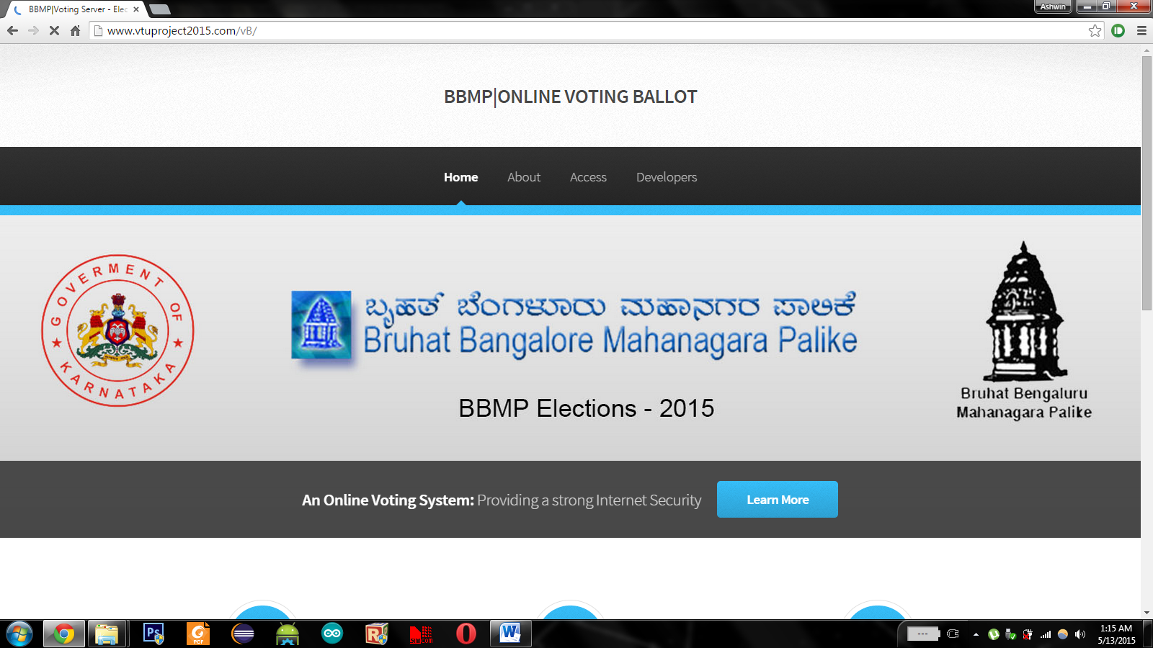

Figure A.1 Main Splash Screen of Voting Ballet